23.43: a) There is no dependence of the potential on 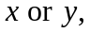 and so it has no components in those directions. However, there is dependence:

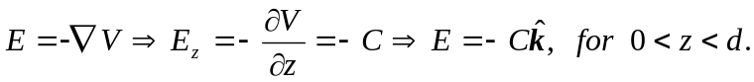
and 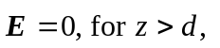since the potential is constant there.

(b) Infinite parallel plates of opposite charge could create this electric field, where the surface charge is 